**A TRIBUTE TO KENNETH JONES, COMMANDER OF THE ORDER OF DISTINCTION, BY the Farquharson Institute of Public Affairs AND JUSTICE OF THE PEACE**

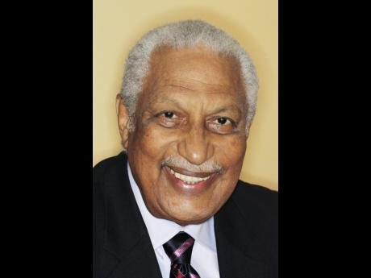

On the death of Kenneth Stanley Jones – July 1, 2015, we salute him with perspectives assembled by FIPA members, including Richard Hopkin, a member from the early days of FIPA. We are deeply saddened by Ken’s death and in paying this Tribute, we convey our condolence to his family at this time of bereavement.

The recent Gleaner editorial mourning the death of veteran journalist, Ken Jones, described the Farquharson Institute of Public Affairs (FIPA), as a “Think Tank”. Ken Jones stated that FIPA might be more aptly described as the forerunner of most of the civil societies of Jamaica.

Founded in 1917 as the Jamaica Imperial Association, its declared objective was to ensure that Jamaicans played a worthy part in the consolidation and development of Jamaica as part of the British Empire and the Commonwealth. But as new occasions demand new duties, the Institute changed its name in 1960 in memory of its founder, Sir Arthur Farquharson, to serve the country in a new dispensation with the everlasting values of the past.

The Institute played a highly influential role in the development of Jamaica. The members were expected to consider, debate and deal with all matters affecting the economic, social, agricultural, industrial or commercial, welfare and development on anyone or anywhere in Jamaica. They were used to create and foster sound public opinion in connection with such matters and express the views of the Institute to the government of Jamaica. The development of numerous other civil societies organised to deal with specific legal, environmental, or political issues may be the reason for the decline in the activities of the Institute.

With that prestigious pedigree, Ken Jones sought to restore the glory of FIPA by recruiting new members to meet the new challenges and some old ones for Jamaica to overcome. Ken Jones envisioned a big Jamaica, a proud Jamaica, a small nation building a sound economy through the application of a wide berth of skills and brilliant strategy.  After all, if Singapore could do it, he asked, why couldn’t we?

Understanding that Singapore’s transitional phase from developing country to First World Nation was in large part due to the transformation of its educational system, some years ago Ken attempted to adopt a primary school in a socially disadvantaged community for Jamaica’s development. Ken’s plan was not to simply feed the school with physical resources but to nourish the school with teachers equipped to use the styles of instruction proven most successful to build the cognitive resources and self-esteem of young children.  Ken wanted to prove that these children could excel regardless of the community in which they were living.

Despite the almost relentless efforts of Ken and his good friend and fellow Councillor Pete Chang, there was a persistent clog present in the process of obtaining a school in which to conduct this experiment. Thankfully, the idea itself has no clogs and cannot perish.

Ken’s voice as he spoke of that school at FIPA Council Meetings conveyed his passion for the idea. He loved FIPA though we do not know the length of time that he served FIPA. The current members saw him there as a welcoming face as thy attended a first meetings.  We listened to his distinctive, clear voice when we planned and successfully implemented public seminars on areas that were vital for development of Jamaica: **Agriculture** as an underperforming industry, **Highway 2000** at its inception, **Executive Agencies** in governance as they were expanding without the people as beneficiaries knowing about them, and **Leadership**. When there was concern about the functioning of the office of the Director of Public Prosecutions, the Institute invited the UK Director of Public Prosecutions to Jamaica to share his ideas on the strategies that sustain law and order.

The Foreword that Ken wrote for a FIPA document may be his last written words. FIPA would therefore like to share with you a passage in the Foreword:

 “*The Biblical book of Proverbs tells us: “Where there is no vision the people perish”. It is a maxim widely quoted with the general understanding that although there may be a “better land” with promises of higher moral and material standards, if “we as a people” cannot conceive it we will not achieve it. To varying degrees individuals will have their personal visions of grandeur; and work successfully toward their goals. However, is a community, of whatever size and type – home, village or nation -- likely to realize visions without first having good leadership? That is the question!*

*There is abundant evidence that a community’s vision is of little value if there is no leader to share it, articulate its message and co-ordinate the required action*.”

Thank you Ken, for the marvellous work you did for FIPA and by extension for Jamaica. We thank the family for allowing us to share him with them.

May his soul rest in peace!

July 27, 2015